**AI ASSINGMENT-12**

**Task 1: Implementing Bubble Sort with AI Comments**

* **Task**: Write a Python implementation of **Bubble Sort**.
* **Instructions**:
  + Students implement Bubble Sort normally.
  + Ask AI to generate **inline comments explaining key logic** (like swapping, passes, and termination).
  + Request AI to provide **time complexity analysis**.
* **Expected Output**:

A Bubble Sort implementation with AI-generated explanatory comments and complexity analysis

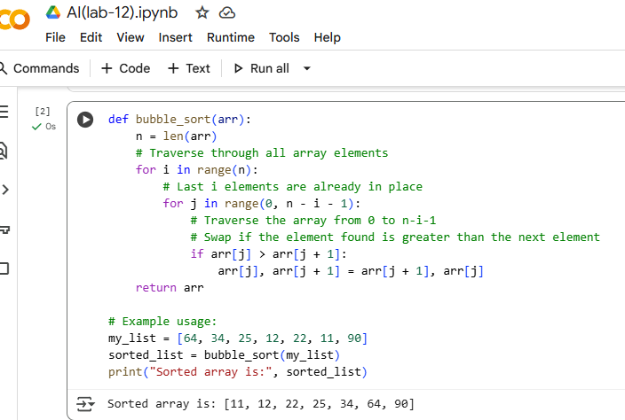

**Explaination:**

The provided code implements the Bubble Sort algorithm. Here's a breakdown of its logic:

1. **Outer Loop:** The outer loop iterates n times, where n is the number of elements in the array. This is because in each pass of the outer loop, at least one element (the largest remaining unsorted element) is placed in its correct sorted position at the end of the unsorted portion of the array.
2. **Inner Loop:** The inner loop iterates through the unsorted portion of the array. In each iteration, it compares adjacent elements (arr[j] and arr[j+1]).
3. **Comparison and Swapping:** If the current element (arr[j]) is greater than the next element (arr[j+1]), the two elements are swapped. This process effectively "bubbles up" the largest elements towards the end of the array.
4. **Reduced Comparisons:** The range of the inner loop decreases with each pass of the outer loop (n - i - 1). This is because the elements at the end of the array (from n - i onwards) are already sorted and in their final positions.
5. **Termination:** After the outer loop completes, the entire array is sorted. The function then returns the sorted array.

In essence, Bubble Sort repeatedly steps through the list, compares adjacent elements and swaps them if they are in the wrong order. The pass through the list is repeated until the list is sorted.

**Task 2: Optimizing Bubble Sort → Insertion Sort**

* **Task**: Provide Bubble Sort code to AI and ask it to suggest a **more efficient algorithm** for partially sorted arrays.
* **Instructions**:
  + Students implement Bubble Sort first.
  + Ask AI to suggest an alternative (Insertion Sort).
  + Compare performance on nearly sorted input.
* **Expected Output**:
  + Two codes (Bubble Sort + Insertion Sort).
  + AI explanation of why Insertion Sort is more efficient for partially sorted data.

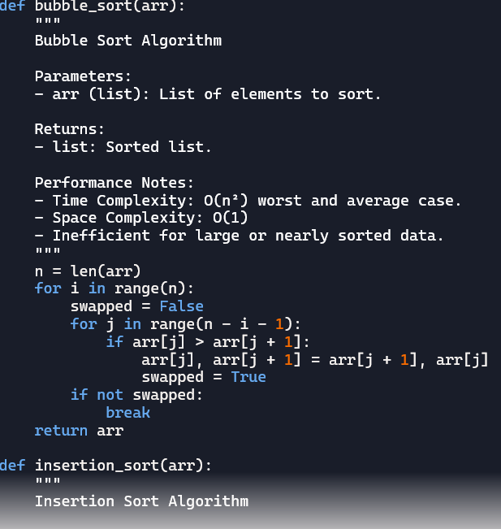

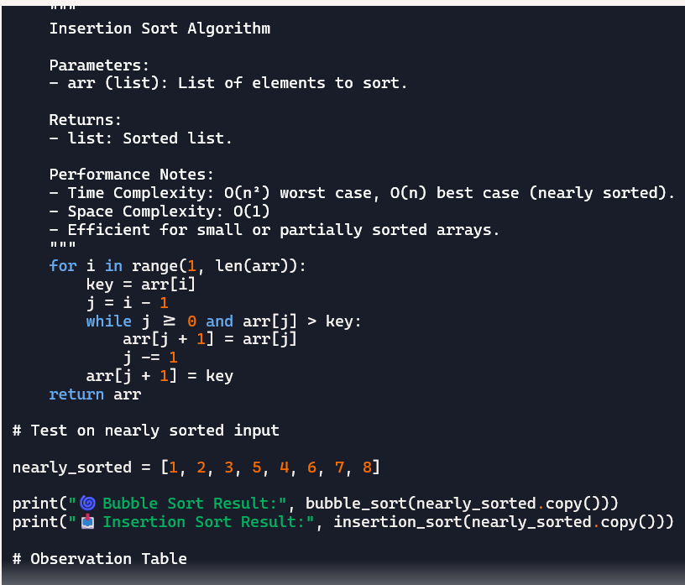

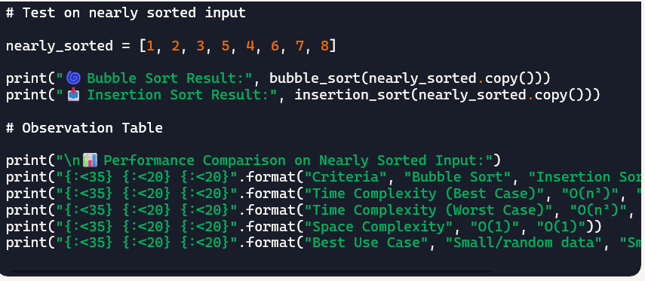

Explaination:

Bubble Sort compares each pair of adjacent elements and swaps them if needed. It keeps doing this until the list is sorted. It's simple but slow—especially on large or nearly sorted data—because it doesn't take advantage of existing order.

• Insertion Sort is smarter for nearly sorted arrays. It builds the sorted list one item at a time, placing each element where it belongs. If most elements are already in order, it finishes quickly with fewer moves.

👉 So, for partially sorted data, Insertion Sort is faster and more efficient than Bubble Sort. It avoids unnecessary comparisons and swaps.

**Task 3: Binary Search vs Linear Search**

* **Task**: Implement both **Linear Search** and **Binary Search**.
* **Instructions**:
  + Use AI to generate docstrings and performance notes.
  + Test both algorithms on sorted and unsorted data.
  + Ask AI to explain when Binary Search is preferable.
* **Expected Output**:
  + Two implementations with docstrings.
  + A student observation table comparing performance (Linear vs Binary Search).

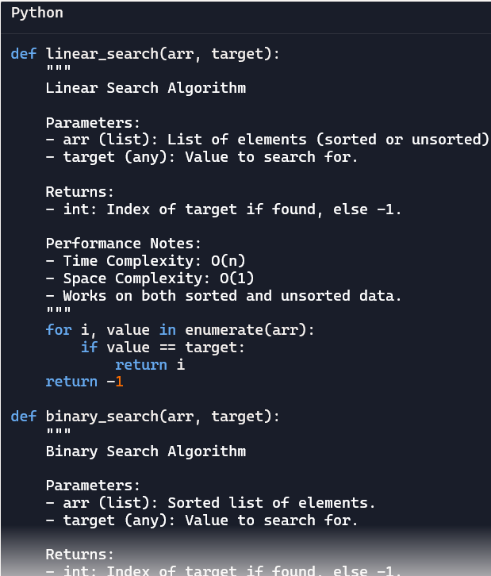

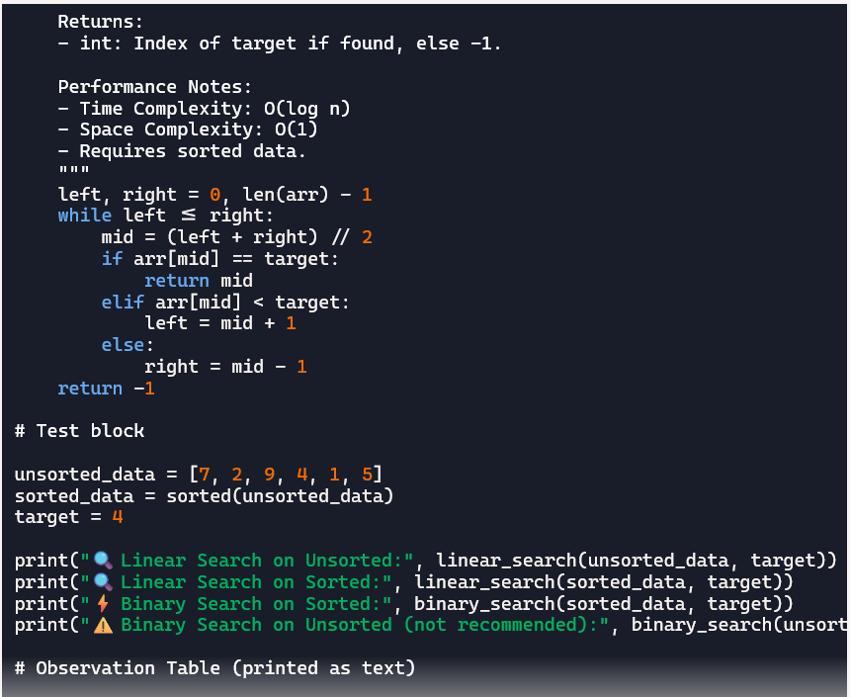

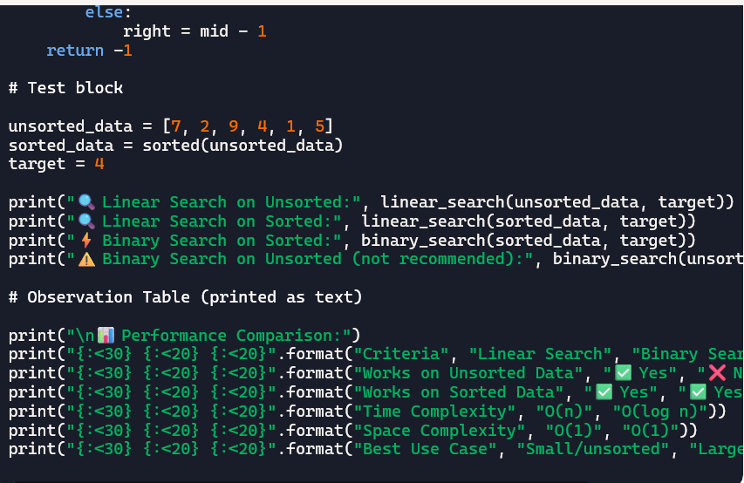

Explaination:

Linear Search

• Checks each element one by one.

• Works on any list—sorted or unsorted.

• Slower for large datasets.

⚡ Binary Search

• Only works on sorted lists.

• Divides the list in half each time.

• Much faster for large datasets.

✅ When is Binary Search Preferable?

• When the list is already sorted.

• When you're searching frequently.

• When the dataset is large and performance matters

**Task 4:** Quick Sort and Merge Sort Comparison

* **Task:** Implement Quick Sort and Merge Sort using recursion**.**
* **Instructions:**
  + Provide AI with partially completed functions for recursion.
  + Ask AI to complete the missing logic and add docstrings.
  + Compare both algorithms on random, sorted, and reverse-sorted lists.
* **Expected Output:**
  + Working Quick Sort and Merge Sort implementations.

AI-generated explanation of average, best, and worst-case complexities

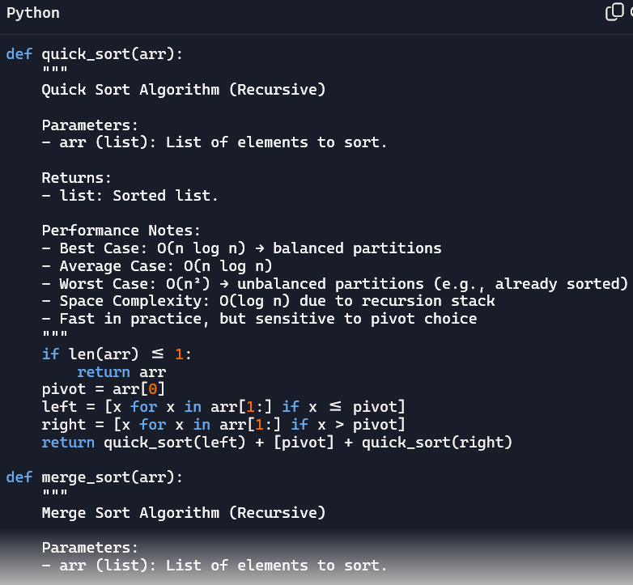

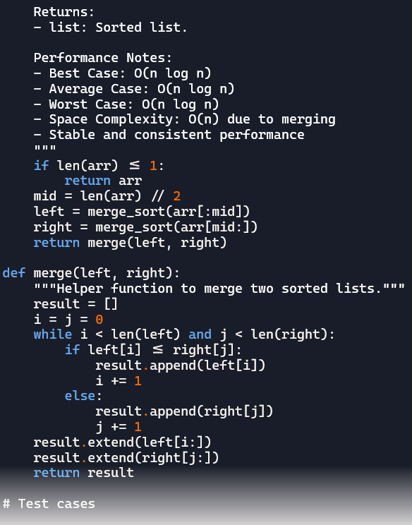

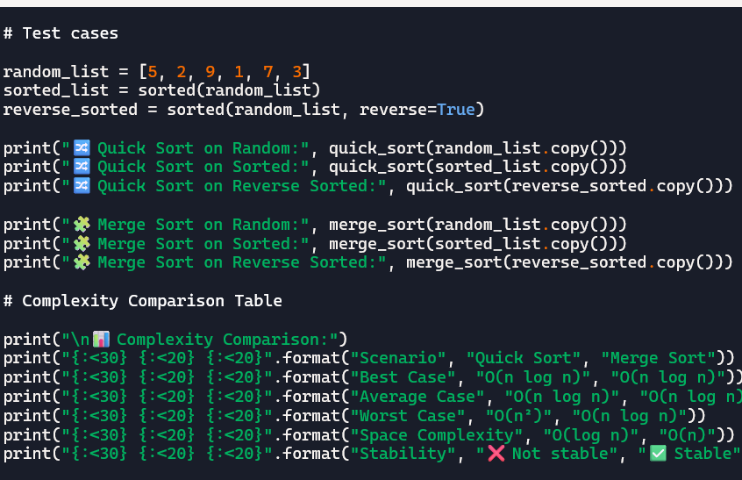

Explaination

🔀 Quick Sort — Step by Step

1. Choose a pivot (usually the first element).

2. Partition the list:

• Create a list with elements ≤ pivot.

• Create a list with elements > pivot.

3. Recursively sort the and lists.

4. Combine: Return .

📌 Example:

List = → Pivot =

Left = , Right =

Sort left → , Sort right →

Final = [1, 2, 5, 9]

Merge Sort — Step by Step

1. Split the list into two halves.

2. Recursively sort each half.

3. Merge the two sorted halves:

• Compare elements from both halves.

• Build a new sorted list by picking the smaller item each time.

📌 Example:

List = → Split into and

Sort each → and

Merge → [1, 2, 5, 9]

**Task 5:** AI-Suggested Algorithm Optimization

* **Task:** Give AI a naive algorithm (e.g., O(n²) duplicate search).
* **Instructions:**
  + Students write a brute force duplicate-finder.
  + Ask AI to optimize it (e.g., by using sets/dictionaries with O(n) time).
  + Compare execution times with large input sizes.
* **Expected Output:**
  + Two versions of the same algorithm (brute force + optimized).

AI explanation of how complexity was improved

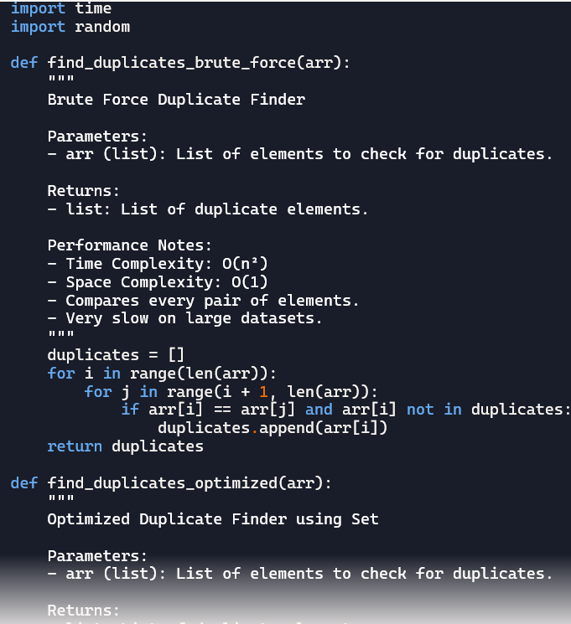

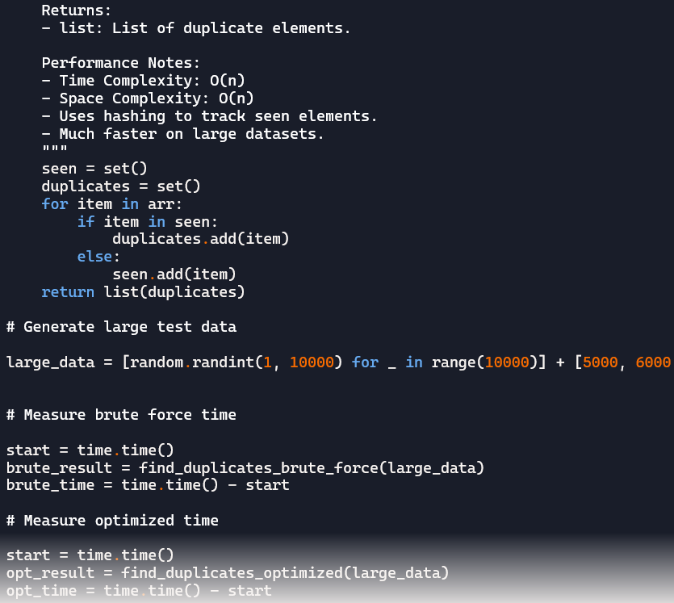

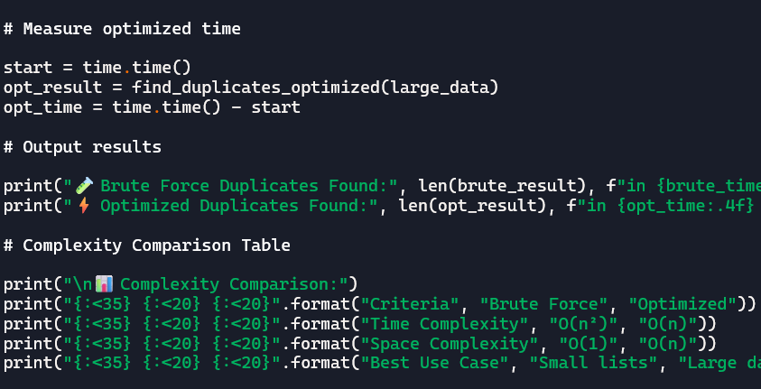

Explaination:

Brute Force Approach (O(n²))

• Compares every pair of elements in the list using nested loops.

• If two elements match and haven’t been recorded yet, they’re added to the duplicates list.

• Time complexity is O(n²) — very slow for large datasets.

• Space complexity is O(1) — no extra memory used beyond the result list.

• Best suited for small lists or teaching basic logic.

⚡ Optimized Approach Using Sets (O(n))

• Scans the list once, storing seen elements in a set.

• If an item is already in the set, it’s added to a duplicates set.

• Uses hashing for fast lookups and insertions.

• Time complexity is O(n) — much faster and scalable.

• Space complexity is O(n) — uses extra memory for sets.

• Ideal for large datasets or performance-critical applications.

Execution Time Comparison

* Brute force takes **much longer** as input size grows.
* Optimized version runs in **milliseconds** even on large lists.
* Demonstrates how algorithm choice affects real-world performance.

🧠 AI Optimization Insight

* Replacing nested loops with hash-based structures (like sets or dictionaries) reduces time complexity.
* This shift from **quadratic to linear** time is a key optimization pattern in algorithm design.

Let me know if you’d like to visualize this with graphs or turn it into a classroom worksheet!

.